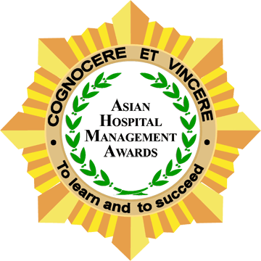
Deadline of Entries: June 11, 2010

Asian Hospital Management Awards 2010

Project Summary Sheet

INSTRUCTIONS FOR USE OF THIS FORM: Please,

- Fill out all the sections below. The total words for all the sections (1-4 below) must not exceed 1,500.
- Send this Form and the accompanying Entry Form to lestiefronteras@exedraevents.com on or before June 11, 2010. ONLY soft (email) entries will be accepted.
- IMPORTANT: It is necessary that the CEO sign on the last page of this form.
- It is understood and accepted that HMA will share the 1,500 word summaries and relevant aspects of the Entry form submitted - on the HMA or related Resource Center website.
- All supporting documents MUST be submitted via courier in CD ROMs with four (4) copies of each CD that you are submitting and all labeled, together with one set of the original hard copy materials to the Asian Hospital Management Awards Steering Committee, address below. Courier and customs charges MUST be prepaid.
Category: Indicate the category in which you are entering this project. The awards categories are: Community Service Project, Customer Service Project, Human Resource Development Project, Internal Customer Service Project, Marketing, PR or Promotional Project, Patient Safety / Quality Medical Care Project and Departmental Service Improvement Project..

Project Title: Provide a (descriptive) name by which you refer to this project

1. Eligibility Criteria: Eligible projects are those that: (i) went into service or start operations between January 2009 to May 2010 or (ii) benefited from material enhancements that were implemented between January 2009 to May 2010.
(1.1) When did the Project go into service or start operations?

(1.2) For Projects that did not start operations between January 2009 and May 2010, what were the material enhancements that took place during this period? Please describe the materiality of these enhancements. If the enhancements you describe are not “material” in nature, the Steering Committee invites you to consider submitting your Project in the future after the implementation of material enhancements.

(1.3) Was this Project previously submitted as an entry to the Asian Hospital Management Awards?
Yes No Others please explain.

If yes, what year?
(1.4) If yes, did this Project previously win an Asian Hospital Management Award? A project that previously won cannot be entered again. However, a project that was a runner-up/merit/excellence award can be entered again.
Yes No Others please explain.
2. Project Description
(2.1) What are the Project’s measurable objectives?

(2.2) Why was the Project selected? What does it seek to improve or correct?

(2.3) Please briefly describe the Project’s implementation, including timeline, key tasks, financial resources, etc.

3. Results Analysis: Panel members assess the Project based on: (i) the significance of the results or outcomes and (ii) the measurability of these results or outcomes.
(3.1) What were the Project’s short-term and long-term qualitative and quantitative results or outcomes that generated benefits to the patients or the hospital? Please describe the relevance of these results/outcomes.

(3.2) What qualitative and quantitative measures were used to track the impact of the Project? Are these the most objective measures available? If not, please explain why objective measures were not utilized.

(3.3) How did the Project benefit the Hospital or its stakeholders? Please describe the nature and magnitude of these benefits. Please provide supporting documents.

4. Supporting documents: (LIST below the supporting documents and materials you are submitting to support the project or program, i.e. brochures, photos, press clippings, etc.)
4.1 | 4.8
4.2 | 4.9
4.3 | 4.10
4.4 | 4.11
4.5 | 4.12
4.6 | 4.13
4.7 | 4.14

I hereby unequivocally certify that all the information indicated is true and correct.

Signature of CEO: Printed Name:

This document comes with 606 words. Please write the total word count for the document here. This is not to exceed 2,106 words

Results:

